# MEGA:BIT (features survey)

## SLACK survey among the teachers community that uses micro:bit

<https://docs.google.com/forms/d/e/1FAIpQLSeVRwZyqfOpxLcQNXQh7lcv9uSoPuKQ7lq_mb9wanPwTjpQ_A/viewform?usp=sf_link>

## Inserting image...

## 1. Do you think having a Mega:bit for demonstration of students’ code to the class would be helpful?

Yes! I would love to have one **(60%)**

Hum... It's an interesting idea depends on the features **(32.5%)**

I don't think it's very useful at this moment **(7.5%)**

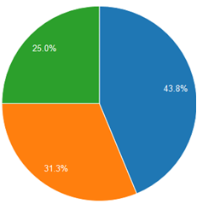

## 2. How large should it be?

About the size of an A4 paper **(44%)**

Bigger than A4 **(31% )**

Smaller than A4 **(25%)**

## 3. Would it be preferable for you to hold it...

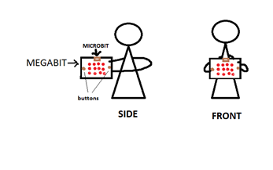

At the side? **(23%)**

In front? **(10%)**

I don't mind **(67%)**

## 4. Would having LEDs at the back be useful/helpful for demonstration?

Yes, so that my neck doesn't hurt **(52%)**

No, it would be confusing **(48%)**

## 5. Which option would you choose for the location of the buttons?

At the front face of the Mega:bit (same position as the Micro:bit) **(72%)**

At the back but with an indicator in the front to show students which button is pressed **(14%)**

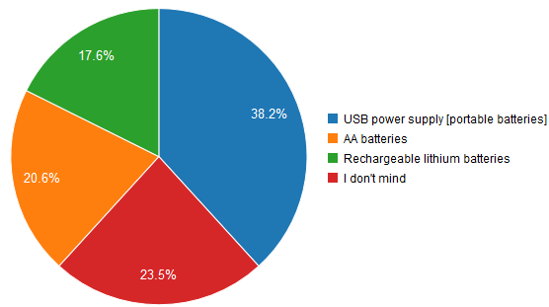I don't mind **(14%)**

## 6. Do you have any preferences batteries wise?

USB power supply [portable batteries] **(38.2%)**

AA batteries **(20.6%)**

Rechargeable lithium batteries **(17.6%)**

I don't mind **(23.5%)**

## 7. Any other features that you would like to see from the Mega:bit?

### Replies

* @mb_slcka

Speaker and headphone socket

* @emmahorsfalla

I just love that I can use it for people with disabilities but have considered putting a handle on for better hold for those that have difficulties

* @countrycedarworksa

speaker, wifi, remote control from wifi, temp, lcd screen, Thank you

* @mwirtha

Durability. Electrical protection of itself and attached micro:bit, e.g., from static electricity from handling on a dry winter day on a wool carpet :-)

* @physicsdavida

Maybe I missed something about a fuller description of the project but is this just a replica of the micro:bit but larger with the added ability to copy the screen image from a micro:bit? As I started answering I thought it was more than that but now I'm not sure. If it is just a large replica, will the other GPIO pins still work? If the purpose is just to show what is on the 5x5 LED screen then I'm not sure I would find much use for it because my students would probably still have to move around to see it but they could just move to see the other student projects. And many of my students embed their microbits in different physical fabricated forms so a larger 5x5 screen would really be helpful there as a teaching tool.

* @tima

No

* @agata.bublewicza

Built-in speaker

* @dailinyanga

compactable with 5v sensors, with 5v power supply, 5v device signal inputs.

* @nicka

no

* @david_msa

stand so it can free stand, think about moving it and storing it for transport in the back of cars etc